Chapter 9, Solution 51.

If the voltage v_{o} across the 2-Ω resistor in the circuit of Fig. 9.58 is 10 cos(2t) V, obtain i_{s}.

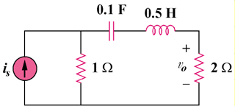

Figure 9.58
For Prob. 9.51.

Solution

The current I through the 2- resistor is
, where

Therefore,
25cos(2t – 53.13) A

